Research Question
How can a sense of home and relaxation be created through the construction and assembly of a lightweight portable system? And can this be transported around with a nomadic person to be manipulated in many ways to fit different situations and locations with ease?

Annotation One
Sarah Murray, “A playful solution to the housing crisis”, December 2017 in Sydney, Australia. TED video, 10:42, Sarah Murray: A playful solution to the housing crisis
- Homelessness
- Game
- house design (architecture)
- Cost efficient
- Waste conscious
In this TED talk the topics that are the main focus of the discussion are issues around the housing crisis and how creating a “game” that allows people to design their dream home and have it delivered to them can help reduce the people who are without houses. Due to the fast nature of this off site construction this therefore eliminates weather as being a determining factor for how long the build takes. Murray addresses the political issues of money and how this is a driver in the decisions that we make, and she also addresses a social issue of the housing crisis and how so many people are without homes due to the expensive nature of building a home, in both time and money.
The information shared in this talk is somewhat reliable given that they use facts and numbers to back up the arguments they are making. Murray throughout the text gets progressively more excited when taking about these housing issues and what her business has been doing to minimize these and aim to get rid of them altogether. It is because of this that the text is very subjective. Murray is suggesting that their “housing game” is the only way and the best way to overcome the housing crisis issue (as a promotion to her business). However, I do agree that she is trying to make it easier for first home buyers to get a house, and the way she is going about doing this to minimize cost and wasted time and only deliver what the customer has requested.
All in all I found this source very helpful as a starting point to generate ideas about how other people in the design industry are thinking about what they are doing and how this is affecting everything else that is going on around them. I also found it very helpful to see how all these ideas of how money, time, waste, planet and humans can link together in design and be utilized in a way that is better for most. However, as this was a very subjective and promotive text I was somewhat disappointed that the negative side was never touched on even slightly, how much material of what they use is recycled, how do they handle the left over material that they did not use? I was left with a lot of questions which has helped me to think even more in-depth about my project and how I can think through a lot of the outcomes that I am proposing and see how they affect not only the humans, but the earth, animals and other life too.

Annotation Two
Maarit, Makala. “Knowing Through Making: The Role of the Artefact in Practice-led Research”. Knowledge, Technology & Policy. (2007). 157-163. Sourced from: https://www.researchgate.net/publication/227320305_Knowing_Through_Making_The_Role_of_the_Artefact_in_Practice-led_Research
- Making
- Products
- Process of inquiry
- Practice-based research
- Artefacts
- Summary:
In this text Maarit questions how art and design practice can combine and interact with research to continue to produce a large amount of new knowledge. How when art and design is combined with research it could create new points of view, and even new and creative ways of doing research. This article explores processes of making and the products of making through the lens of an artefact made by an artist-researcher, and how these are used to help give answers to the questions and research being conducted. This text identifies a lot of historical and political issues around the idea of determining what is research and what is design.
Right from the very start of this text the information that is given to us is very subjective and argumentative. The author argues that the area of art and design has a place in the field of academic research. She does this by explaining art as a process of inquiry, instead of just a fun outlet for children. Even though this text maybe highly bias I am really drawn to it and agree strongly with the points that are being made. Rationale as to why the field of art and design belongs in the area of academic research because there is so much more research, planning, collecting and evaluating of information that goes into an “art piece” than people initially realise. Whether the outcome is a collection of answers to a question or an argument against a viewpoint the artefact has been designed in a way to spark up conversation and is an answer to a set of prompts.
I was really drawn to this text as I feel is relates very strongly to what I am studying currently, an art and design research degree. Reading this text has given me a better insight into how I can carry out my research and how making models and prototypes alongside this don’t have to directly answer the questions that I am proposing to act as useful material for my research. Rather they can create a new series of questions or even arguments against it. For example making a series of prototypes of a shelter for a nomadic person, but keeping them in the small scale of a book. This would show that these models could be usable and lived in if they were at a much larger scale, but since they are not the idea of living in them is still offered but the practical notion of being able to crawl into the shelter is not possible.

Annotation Three
Jasmax, Soapbox Sculpture, 2019. Reinforced concrete, Steel and Pigmented Glass. Auckland.
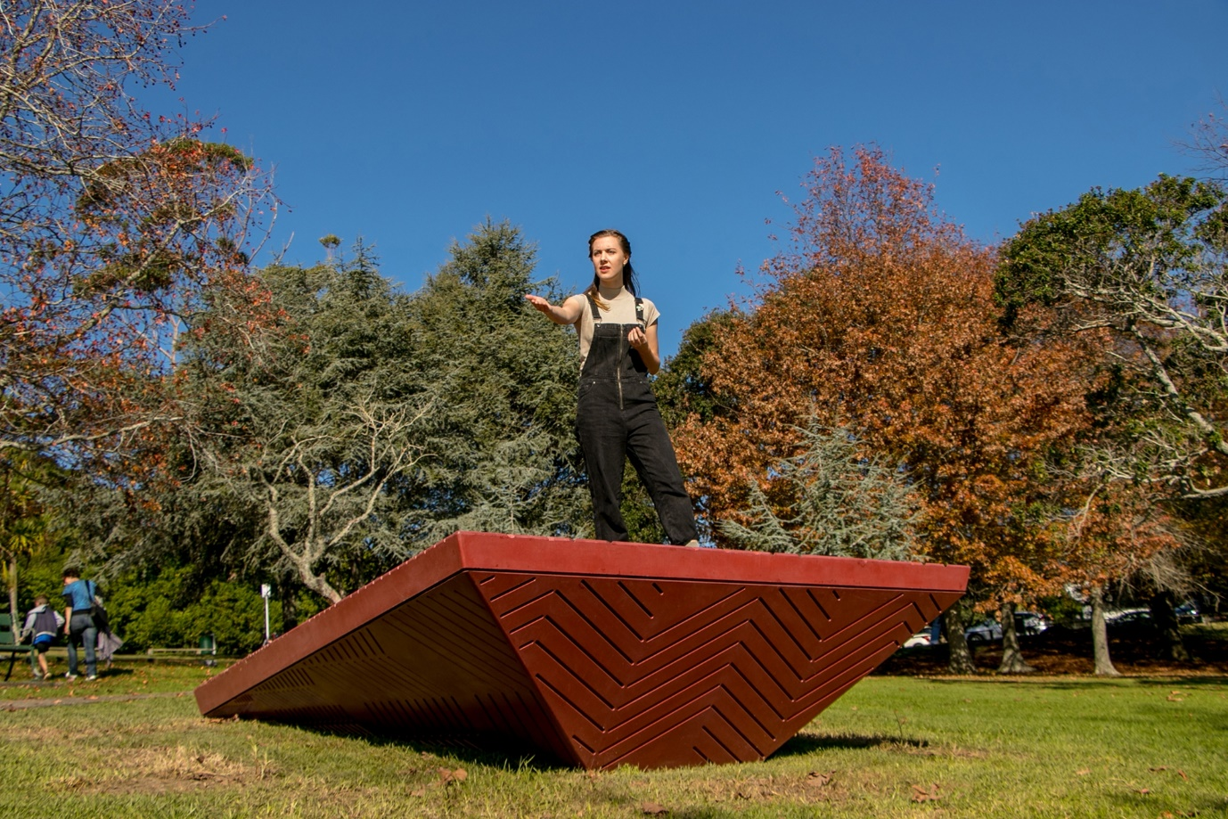
Fig.1. A striking architectural sculpture designed by an all-women team, Soapbox celebrates 125 years of women’s suffrage in New Zealand. Created by Jasmax. From the Jasmax project gallery website. https://www.jasmax.com/projects/featured-projects/soapbox-stories/
- Temporal
- Speaking platform
- Soapbox
- Interactive
- Observed
This sculpture has been designed and build to act as a structure to acknowledge the 125-year history of women’s suffrage in New Zealand. Designed and built by an all women team this Soapbox Sculpture optimises the strength that women in numbers can have. The main goal of the soapbox is to create and give a space for people to speak. However in his case the main goal of the sculpture is to highlight the history of women’s suffrage in New Zealand but his soapbox is anything by exclusive, even though it only had a temporal lifespan the sculpture aimed to give a space that everyone could come to speak from, observe, stand on and even sit on.
This information is very reliable but highly subjective as it is right from the mouth of the designer. Usually how the designer intends the design to be utilised isn’t always the way the design ends up being interpreted. However, in this case the designer played on the temporal aspect of the design and used this to run speaking events on the soapbox. Even though the physical happenings of the soapbox were only temporal, the consequences of the sculpture and its conversations will be ongoing. In the words of Kate Sheppard “because women are endowed with a more constant solicitude for the welfare of the rising generations, thus giving them a more far-reaching concern for something beyond the present moment”. So, even though the soapbox sculpture no longer exists the issues in which it addressed will continue.
this idea of creating a temporal “event” through the means of a physical structure resonated strongly with me in relation to my own research area. Temporal modular structures are what I am interested in creating to render my message of what it is like to live as a nomadic person, and how people can only live by the essential items that they can carry. However, my interpretation of an event is much different to the speaking events that took place on the soapbox. Instead, the structure would be used to create a sense of home for the nomadic person and the conversation would be between the nomad and the structure. How they live together, coexist, being and object.

